Belgrave South Primary School

PRINCIPAL: STUART BOYLE
175 COLBY DRIVE, BELGRAVE SOUTH 3160
TELEPHONE: 03 9754 2505 FACSIMILE: 03 9754 6433
EMAIL: belgrave.south.ps@edumail.vic.gov.au
WEB: www.belgravesouthps.vic.edu.au
ABN: 333 96901 815

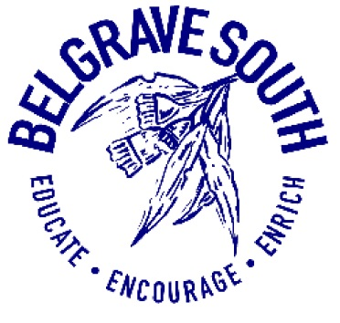

Inclusion and Diversity Policy

Purpose
The purpose of this policy is explain Belgrave South Primary School’s commitment to making sure every member of our school community, regardless of their background or personal attributes, is treated with respect and dignity. Belgrave South Primary School strives to provide a safe, inclusive and supportive school environment for all students and members of our school community.
Policy
Definitions
Personal attribute: a feature of a person’s background or personal characteristics that is protected by State or Commonwealth anti-discrimination legislation. For example: race, disability, sex, sexual orientation, gender identity, religion etc.

Inclusion and diversity
Belgrave South Primary School is committed to creating a school community where all members of our school community are welcomed, accepted and treated equitably and with respect regardless of their backgrounds or personal attributes such as race, language, religious beliefs, gender identity, disability or sexual orientation so that they can participate, achieve and thrive at school.
Belgrave South Primary School acknowledges and celebrates the diversity of backgrounds and experiences in our school community and we will not tolerate behaviours, language or practices that label, stereotype or demean others.
Belgrave South Primary School will:
- ensure that all students and members of our school community are treated with respect and dignity
- ensure that students are not discriminated against and where necessary, are accommodated to participate in education and all school activities (eg schools sports, concerts, excursions, incursions, camps) on the same basis as their peers
- acknowledge and respond to the diverse needs, identities and strengths of all students
- encourage empathy and fairness towards others
- challenge stereotypes that promote prejudicial and biased behaviours and practices
- contribute to positive learning, engagement and wellbeing outcomes for students.
Belgrave South Primary School is committed to lifelong learning by providing an inclusive, supportive and nurturing community in which diversity is valued and celebrated. Our innovative curriculum and culture of excellence creates a stimulating learning environment that engages and challenges students to achieve personal success and make positive contributions to society.

Bullying, harassment and other forms of inappropriate behaviour targeting individuals because of their personal attributes will not be tolerated in our school community. Students who may have experienced or witnessed this type of behaviour are encouraged to speak up and to let their teachers, parents or carers know about those behaviours to ensure that inappropriate behaviour can be addressed.
Belgrave South Primary School will take appropriate measures, consistent with its Student Engagement and Inclusion Policy, to respond to discriminatory behaviour or harassment at our school. Students that are involved in bullying or harassing others on the basis of their personal attributes will be supported to understand the impact of their behaviour.
Belgrave South Primary School also understands that it has a special obligation to make reasonable adjustments to accommodate students with disabilities. A reasonable adjustment is a measure or action taken to assist all students to participate in their education on the same basis as their peers. Reasonable adjustments will be made for students with disabilities through our Student Support Group processes in consultation with the student, their parents or carers, their teachers and if appropriate, their treating practitioners. For more information about support available for students with disabilities, please refer to our school’s Student Engagement and Inclusion and Diversity Policy or contact the Principal/Assistant Principal on 97542505 for further information.
Related policies and resources
Related policies:

- Student Engagement Policy
- School Child Safety Policy
- Bullying and Harassment Policy

EVALUATION:
This policy will be reviewed as part of the school’s 3-year review cycle.

Policy Ratified August 2019
Review Date August 2021

