Belgrave South Primary School
Principal: Stuart Boyle
175 Colby Drive, Belgrave South 3160
Telephone: 03 9754 2505 Facsimile: 03 9754 6433
EMAIL: belgrave.south.ps@edumail.vic.gov.au
WEB: www.belgravesouthps.vic.edu.au
ABN: 333 96901 815

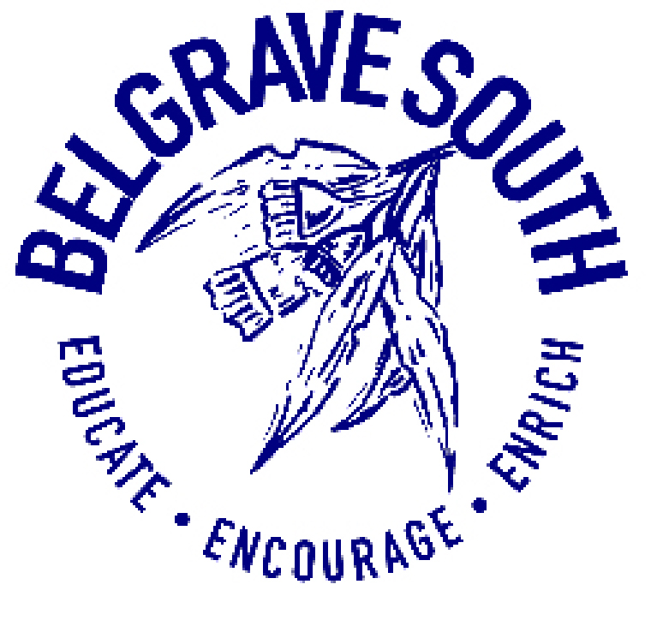

Curriculum Framework Policy

OVERVIEW
Curriculum covers all arrangements the school makes for students’ development and learning. It includes the course content, student activities, teaching approaches, the way in which teachers and classes are organised and decisions on the need for and the use of facilities and resources.
Belgrave South Primary School Primary School is committed to seeing our children achieve to a high level in all academic areas but also to provide students with the best possible foundation in life through a well-rounded education, which values the skills, interests and abilities of our students. Our school’s vision is to foster and encourage an inclusive community of learners- ‘learning together’ who are confident, creative and challenged to achieve their full potential within a safe, happy and supportive environment.
To embed this, the school provides sequential learning and teaching programs that deliver a comprehensive, broadly based and inclusive curriculum to all students whilst working to foster an increasing sense of student voice and learner agency. We have high expectations for all students academically, socially and culturally by striving for excellence, honouring the school’s values of Respect for YOURSELF, RESPECT for OTHERS and RESPECT for the ENVIRONMENT.
The school provides a comprehensive curriculum with a strong focus on literacy and numeracy. In addition to the comprehensive classroom programs offered in literacy and numeracy, an integrated classroom curriculum program addresses the curriculum areas of Science, Humanities/History, Technologies/Design Technology, Civics and Citizenship, and Health. Specialist teachers provide instruction in Physical Education, Language (Japanese), and Visual Arts.
Interdisciplinary, personal and social capabilities are addressed within these curriculum areas and supported by a range of camps, excursions, incursions and interschool initiatives. The school is an active participant in district sport competitions as well as providing opportunities for students to participate in instrumental music, district and community events.
Our teachers work in teams across levels to ensure that the Victorian Curriculum is implemented across the school.
Intervention approaches such as Literacy/Numeracy Intervention, the placement of Education Support Staff, the development of individual learning plans and modified programs for individual students and provide additional support for students when needed.
The school structure includes a Leadership team, which supports School Improvement Teams to focus on school improvement priorities outlined within the School Strategic Plan and Annual Implementation Plans, along with
Professional Learning Communities that focus on embedding high quality and consistent curriculum, assessment and pedagogical practice throughout the school.

1. CURRICULUM GUIDELINES
- Our school will recognise and respond to diverse student needs when developing its annual curriculum programs and curriculum plan. Reasonable adjustments will be made for students with disabilities in both the planning and assessment of their learning. The school is committed to providing culturally appropriate and inclusive programs to Koorie students through supporting the development of high expectations and individualised learning plans for Koorie students. Creating an environment that respects, recognises and celebrates cultural identity through our practices and curriculum is also highly valued.
- Our school will comply with all DET guidelines about the length of student instruction time required in
- Victorian Government schools.
- Supporting students with transition into school, through school and on to secondary education will be a focus within our school.
- BELGRAVE SOUTH PRIMARY SCHOOL PRIMARY SCHOOL CURRICULUM FRAMEWORK POLICY
- Belgrave South Primary School Primary School – Curriculum Framework Policy VRQA Registration Requirement
- Scope and sequence and team planning documents will be aligned with the Victorian Curriculum F-10, which specifies the skills children and young people need for success in work and life.
- Teaching and learning programs will be resourced through Program Budgets.
Curriculum areas will include:
LEARNING AREAS | CAPABILITIES
THE ARTS  Dance  Drama  Media Arts  Music  Visual Arts  Visual Communication  Design  ENGLISH  HEALTH AND PHYSICAL EDUCATION  THE HUMANITIES  Civics and Citizenship  Economics and Business  Geography  History  LANGUAGES  MATHEMATICS  SCIENCE  TECHNOLOGIES  Design and Technologies  Digital Technologies | Critical and Creative Thinking  Ethical  Intercultural  Personal and Social

2. PROGRAM OVERVIEW
Program Development
- Belgrave South Primary School Primary School will provide a variety of programs that will address the specific needs of students in relation to gender, special learning needs, disabilities and impairments, giftedness, indigenous background and students from language backgrounds other than English.
- The school will identify and cater for the different needs of particular cohorts of students when developing its curriculum plan.
- The Victorian Curriculum will be used as a framework for curriculum development and delivery at Foundation to Year 10 in accordance with DET policy and Victorian Curriculum and Assessment Authority (VCAA) guidelines.
- In developing its Curriculum Plan, the school will provide at least 25 hours of student instruction per week.
- The school will implement the Framework for Improving Student Outcomes (FISO) which provides a model for
- continuous school improvement and uses the following four critical phases:
- Evaluate and diagnose
- Prioritise and set goals
- Develop a plan
- Implement and monitor
Program Implementation
- The school will determine the curriculum program for the following year, based on provision needs and departmental policy requirements.
- To facilitate curriculum planning and implementation, scope and sequence documents, assessment criteria, record keeping documentation and common templates will be used.
- The use of Information and Communications Technologies (ICT) will be integrated across the curriculum to support the improvement of teaching and learning outcomes and adheres to DET’s School Policy & Advisory
- Guide ‘Using Digital Technologies to Support Learning and Teaching’ and the school’s own Digital Media policy.
- The curriculum will be implemented in accordance with the school’s Time Allocation per Learning Area outline
(Appendix A). Time Allocations per Learning Area
Curriculum and Teaching Practice Review
- The school’s curriculum will be audited and reviewed on a cyclical basis to ensure currency with the Victorian
- Curriculum. Curriculum audits and review will inform future curriculum planning and implementation. The school’s leadership team will oversee teacher practice and work to create a culture of learning, collaboration and continuous improvement. Giving and receiving productive feedback will be a key component of teaching practice improvement.
- All staff will participate in the staff performance and development process in which goals are aligned with the school’s Annual Implementation Plan and the Australian Institute of Teaching and School Leadership (AITSL) standards.
- The school will utilise DET policy and guidelines, online resources, internal and external expertise, mentoring and coaching, peer observation and collegiate feedback to continually improve their method and practice of teaching.
The implementation of Professional Learning Communities will support teachers to utilise student learning data to reflect upon and improve their teaching practice.

3. STUDENT LEARNING OUTCOMES STATEMENT
Student learning is produced, shaped and affected by four connected components. Each of these components plays a separate and distinct role in the process of student learning and each is interconnected with all of the others.
Student Learning
Lea

Curriculum (what)
Lea

Pedagogy (how)
Lea

Assessment (how well)
Lea

Reporting (where)
Lea

Curriculum defines what it is that students should learn, and the associated progression or continuum of learning. Belgrave South Primary School Primary School follows the Victorian Curriculum F-10, including Levels A, B, C, and D towards Foundation for individual students.
Pedagogy describes how students will be taught and supported to learn
Assessment identifies how well a student has (or has not) learnt specified content. Teachers follow the Belgrave South Primary School Primary School Assessment Schedule which is reviewed annually.
Reporting explains to the student and the parent where a student is on a learning continuum at the end of a specified period of schooling, and where this places them in relation to their own learning goals, and/or the learning of their peers (through comparison to achievement standards).
The school will document, through its School Strategic Plan and the Annual Implementation Plans, the key strategies for improvement in student learning outcomes as part of our curriculum plan. Data plays a key part in the ongoing school improvement process.
Data Collection:
- The school will continuously monitor student outcomes using a variety of assessment strategies and tools that include: (eg. NAPLAN, English Online Interview, Mathematics Online Interview, Fountas and Pinnell
- Benchmark Assessment, Essential Assessment, PAT Reading and PAT Math and On Demand Assessments).
- Teachers will also develop rigorous formative assessment practices so that they and their students can work together consistently and systematically to gather evidence of learning, provide feedback to each other and set individual learning targets.
Data analysis:
- All teaching staff will implement the school’s assessment schedule. A variety of approaches will then be used to analyse data at an individual, group, cohort and/or school level.
- The use of data will inform curriculum planning including the identification of goals, targets and key improvement strategies in the School’s Strategic Plan and Annual Implementation Plans.
- The School Leadership Team will work with teachers (at an individual, team or whole school level) ensuring a comprehensive understanding of the importance of data, how to interpret it and how to use data to plan for continued improvement in both teaching and learning.
- The School Leadership Team, in consultation with School Improvement Teams, will track whole school data, cohort and/or individual data, and identify potential teaching and learning areas that require further focus.
- Professional Learning Communities (PLCs) will track cohort and individual data to also identify teaching and learning areas that require further focus.
- Data will be used to determine student support options for those at risk, which may include developing an
- Individual Learning Improvement Plan, provision of extra teaching support and/or referral for further assessments.
- Data will also be used to identify students working above the expected level and to determine school actions or programs that could challenge, extend and meet student needs.
Data and Achievement Reporting:
Data will be reported in different ways according to the audience.
For Students: Feedback will be given about current learning and areas for future learning.
For Staff: Both informal and formal data will be used to inform planning and teaching on both a short and long term basis. Trend data will also provide relevant information about the school’s continuous improvement journey.
For parents: Student reports, parent/teacher meetings and electronic student work samples or learning tasks will provide an opportunity for teachers to provide feedback regarding student achievement.
Formal reports are provided at the end of Term 2 and Term 4.
Student Support Group meetings provide a shared opportunity for parents and staff to reflect on the progress of students who have an individual learning plan.
For Community: Student learning outcomes data will be reported in the Annual Report to the School Community provided to the DET, and also available on the State Register maintained by the Victorian Registration and Qualifications Authority and on the school website. A community meeting is held each year for the purpose of sharing the School Annual report to interested parties.
Belgrave South Primary School Primary School – Curriculum Framework Policy VRQA Registration Requirement
FURTHER INFORMATION AND RESOURCES:
- Appendix: Time allocation per Learning Area (F-6)
- DET School Policy and Advisory Guide:
- Curriculum
- Assessment
- Framework for Improving Student Outcomes
- Using Digital Technologies to Support Learning and Teaching
- Student Wellbeing and Learning
- Students with Disabilities
- Koorie Education
- VCAA Revised Curriculum Planning and Reporting Guidelines
- School Assessment Schedule
EVALUATION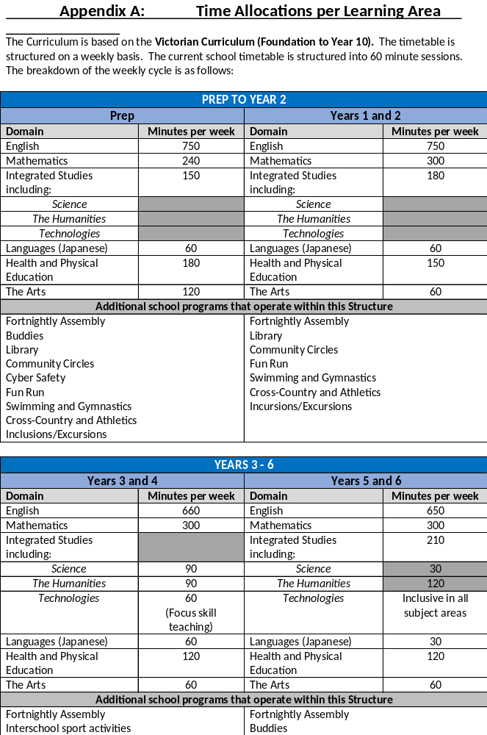
This policy will be reviewed every two years to ensure that school practices reflect current curriculum guidelines and evidence based pedagogy and assessment practices.

Review Cycle
THIS POLICY WAS updated BY SCHOOL COUNCIL ON August 2020
It is scheduled for evaluation and review in August 2022

Appendix A: Time Allocations per Learning Area

The Curriculum is based on the Victorian Curriculum (Foundation to Year 10). The timetable is structured on a weekly basis. The current school timetable is structured into 60 minute sessions. The breakdown of the weekly cycle is as follows:

PREP TO YEAR 2
Prep |  | Years 1 and 2
Domain | Minutes per week | Domain | Minutes per week
English | 750 | English | 750
Mathematics | 240 | Mathematics | 300
Integrated Studies including: | 150 | Integrated Studies including: | 180
Science |  | Science
The Humanities |  | The Humanities
Technologies |  | Technologies
Languages (Japanese) | 60 | Languages (Japanese) | 60
Health and Physical Education | 180 | Health and Physical Education | 150
The Arts | 120 | The Arts | 60
Additional school programs that operate within this Structure
Fortnightly Assembly  Buddies  Library  Community Circles  Cyber Safety  Fun Run  Swimming and Gymnastics  Cross-Country and Athletics  Inclusions/Excursions |  | Fortnightly Assembly  Library  Community Circles  Fun Run  Swimming and Gymnastics  Cross-Country and Athletics  Incursions/Excursions

YEARS 3 - 6
Years 3 and 4 |  | Years 5 and 6
Domain | Minutes per week | Domain | Minutes per week
English | 660 | English | 600
Mathematics | 300 | Mathematics | 300
Integrated Studies including: |  | Integrated Studies including: | 180
Science | 90 | Science
The Humanities | 90 | The Humanities
Technologies | 60  (Focus skill teaching) | Technologies | 120
Languages (Japanese) | 60 | Languages (Japanese) | 60
Health and Physical Education | 120 | Health and Physical Education | 180
The Arts | 60 | The Arts | 60
Additional school programs that operate within this Structure
Fortnightly Assembly  Interschool sport activities  Library  Fun Run  Swimming and Gymnastics  Cross-Country and Athletics  Inclusions/Excursions  Camp  Values/Social Wellbeing/Community circles |  | Fortnightly Assembly  Buddies  Library  Cyber Safety  Interschool sports and Lightening Premierships  Secondary School Orientation Program  Swimming and Gymnastics  Camp  Incursions/Excursions

