2015 Annual Report to
the School Community

  Belgrave South Primary School
  School Number: 3551
 |  | 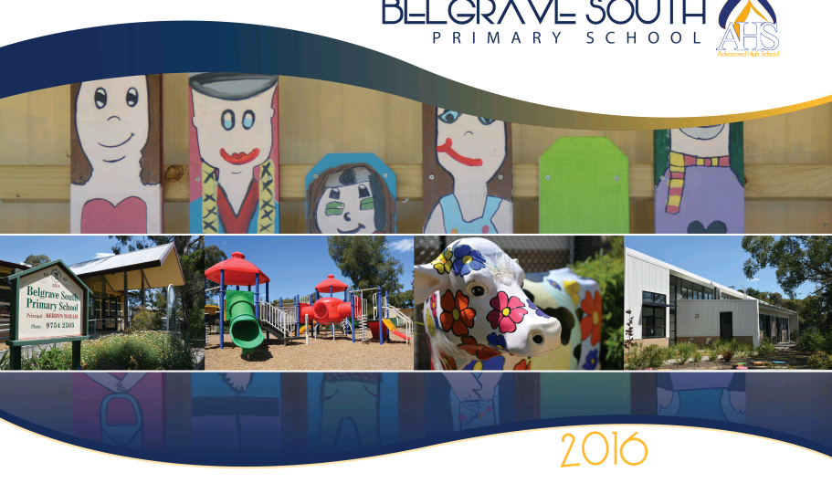 |  | 
 |  |  | 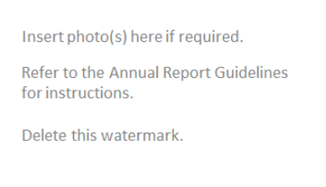
  Kerryn Baillie
  Name of School Principal:
  Peter Hoefler
  Name of School Council President:
 |  |  |  | 10 March 2016
  Date of Endorsement:

All Victorian government school teachers meet the registration requirements of the Victorian Institute of Teaching (www.vit.vic.edu.au).

This school meets prescribed minimum standards for registration as regulated by the Victorian Registration and Qualifications Authority (VRQA) in accordance with the Education and Training Reform Act 2006, inclusive of those schools granted an exemption by the VRQA under the 'Student enrolment numbers' and/or 'Curriculum framework for schools - languages program' minimum standards until 31 December 2015.

About Our School

School Context

Belgrave South Primary School has been providing excellence in teaching and learning for over 100 years. The school, located in the Dandenong Ranges, provides well-equipped grounds and buildings in a beautiful setting.

The school values are: Respect Self, Respect Others and Respect the Environment.

Student wellbeing is a high priority and BSPS is one of the first schools in the Dandenong Ranges to take part in the School-Wide Positive Behaviour Framework. Students enjoy rigorous teaching with enhancement from a wide range of specialist programs. Staff are committed to providing pastoral care through student wellbeing programs whilst incorporating a range of teaching strategies to cater for multiple intelligences across the diversity of student learning needs. In 2015 BSPS was successful in securing National School Chaplaincy funding and our school chaplain enhances our student welfare approach by working with individuals and groups.

The school community is committed to continually improve the school and striving for continued academic excellence in all curriculum areas. The explicit teaching and learning of literacy and numeracy is a high priority as well as developing student’s skills across the curriculum.

BSPS has a unique facility in Sophie’s Restaurant which operates weekly providing opportunities for students to gain skills from growing ingredients to serving a 2 course meal to peers and community members.

The school has 17.88 Effective Full Time Staff; 2 Principal Class Officers, 11.88 Classroom Teachers and 4 Education Support Officers.

Achievement

Teacher assessments and NAPLAN assessment indicate students at BSPS achieving above state in both English and Mathematics. The growth in the year 5 matched cohort in NAPLAN 2013-2015 shows an average of 70% of students achieving medium to high academic growth is all areas. NAPLAN 4-year average in Numeracy is significantly above the state and like school comparisons.
All staff continue to work collaboratively and complete Professional Development to improve teaching including the following strategies: Phonemic Awareness training, CAFÉ framework in reading, Life-Long Writers approach, Toe By Toe Reading support program, BSPS Spelling Scope and Sequence, Word Study support programs, and the implementation of our own SURF Mathematics framework. Strategic PD sessions focused on moderating student achievement outcomes and explicit teaching.

Network professional development sessions and the employment of a numeracy expert consultant enhance explicit teaching and knowledge of effective teaching strategies in both English and Mathematics. Staff will continue to plan and deliver explicit targeted teaching and learning activities as a result of diagnostic strategies to support the individual learning needs of all students at Belgrave South Primary School.

Engagement

Attendance data is ‘similar’ to like school comparisons. Staff continue to work closely with families to promote the importance of attendance. The attendance rates for the school range between 92% and 95%, all though this is an acceptable range staff are working to improve further. Further analysis of the data shows that we have a few students with significant attendance issues and these are presently being addressed with individual attendance plans and the intervention of DET Visiting teachers. The plans involve setting targets with the students in consultation with parents. Education Learning Plans are developed at the individual, class and whole school level. In some plans we have incorporated the services of a child psychologist and family counsellors through OnPsych plans thus providing regular professional support at no cost to the families. The school also provided mentors through the Kids Hope Program to cater for students needing additional support. The School Chaplain worked to support students and family within the school community.
High attendance can also be attributed to the stimulating and engaging curriculum offered at BSPS with students indicating an above state ‘Connectedness to School’.

Wellbeing

The 2015 Attitudes to School Survey (Years 5 & 6) indicated ‘Similar’ opinions to like school comparisons. Staff Opinion Survey was well above state expectations in all areas, this is a clear indication of the increased positive culture being developed and the academic results support this. Parent Opinion survey has improved and is at state expectations.
Much time has been spent developing a common approach to behavior management with the staff training is the School-Wide Positive Behaviour Framework. This was launched to students in 2015 with a come approach ‘Gotchya’s’ throughout the school to encourage and identify respectful behaviours.
Our extensive transition programs are a source of pride for our school, Kinder to Foundation program is well established and continues provide for enrolling students into our school over a 6 month period. Teachers of students in grade 5 and 6 work closely with the local secondary college staff to pave the way for a smooth transition into the next phase of student’s education.

Productivity

At Belgrave South Primary School we effectively allocate and use resources, supported by evidence and adapted to our unique context of our school. We use our human resources, time, space, funding, facilities to the best possible effect and in the best possible combination to support improved student outcomes and achieve our goals and targets. Through careful planning and budgeting we are proud of the extra resources and programs offered at Belgrave South Primary School to support the growth and development of our students. The alterations of our original school building turning it into Sophie’s restaurant gives our students a unique learning space. With School councils support we have seen the continued implementation of SURF mathematics through the employment of a mathematics specialist. The Staxafun Fete and the Parents & Friends raise in excess of $30000 annually and provide further opportunities and equipment for our students and school community.

For more detailed information regarding our school please visit our website at
http://www

  Performance Summary
The Government School Performance Summary provides an overview of how this school is contributing to the objectives of the Education State and how it compares to other Victorian government schools.

All schools work in partnership with their school community to improve outcomes for children and young people. Sharing this information with parents and the wider school community will help to deliver community engagement in student learning in the school, which is a state-wide priority of the Framework for Improving Student Outcomes.

School Profile

Enrolment Profile

A total of 256 students were enrolled at this school in 2015, 128 female and 128 male.
There were 2% of EAL (English as an Additional Language) students and < 10% ATSI (Aboriginal and Torres Strait Islander) students.

  Overall Socio-Economic Profile
  Based on the school's Student Family Occupation index which takes into account parents' occupations.
  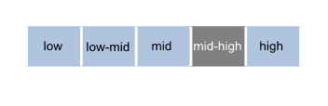
Parent Satisfaction Summary

Average level of parent satisfaction with the school, as derived from the annual Parent Opinion survey. The score is reported on a scale of 1 to 7, where 7 is the highest possible score.

  
School Staff Survey

Measures the percent endorsement by staff on school climate derived from the annual School Staff survey. The percent endorsement indicates the percent of positive responses (agree or strongly agree) on school climate from staff at the school.

Data are suppressed for schools with fewer than three respondents to the survey for confidentiality reasons.

  

  Performance Summary
  Achievement
  Student Outcomes
  School Comparison
  Teacher Assessments from the Australian Curriculum/Victorian Essential Learning Standards (AusVELS)
  Percentage of students in Years Prep to 6 with a grade of C or above in:
  • English
  • Mathematics
  The grades are the same as those used in your child's end of year report.
  A 'C' rating means that a student is at the standard expected at the time of reporting.
  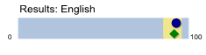
  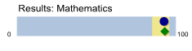
  
  Towards Foundation Level AusVELS is not used for the School Comparison.
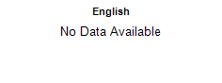
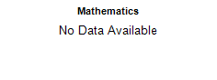

Towards Foundation Level AusVELS

Learning gain of students, relative to expectation in a year, for all students working within Towards Foundation Level AusVELS (AusVELS A to D).

Data will not be displayed where less than 10 student assessments were provided.

  Performance Summary
  Achievement
  Student Outcomes
  School Comparison
  
NAPLAN Year 3

The percentage of students in the top 3 bands of testing in NAPLAN at Year 3.

Year 3 assessments are reported on a scale from Bands 1 - 6.

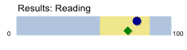
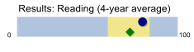
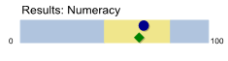
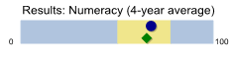

NAPLAN Year 5

The percentage of students in the top 3 bands of testing in NAPLAN at Year 5.

Year 5 assessments are reported on a scale from Bands 3 - 8.

  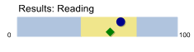
  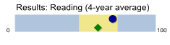
  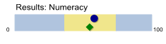
  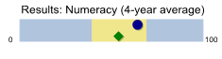
  

  Performance Summary
  Achievement
  Student Outcomes
  School Comparison
  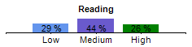
  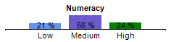
  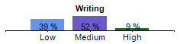
  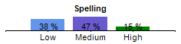
  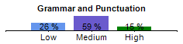
  NAPLAN Learning Gain does not require a School Comparison.
NAPLAN Learning Gain
Year 3 - Year 5

Learning gain of students from Year 3 to Year 5 in the following domains; Reading, Numeracy, Writing, Spelling and Grammar and Punctuation.

NAPLAN learning gain is determined by comparing a student's current year result to the results of all ‘similar’ Victorian students (i.e. students in all sectors in the same year level who had the same score two years prior). If the current year result is in the top 25%, their gain level is categorised as ‘High’, middle 50%, is ‘Medium’ and bottom 25%, is ‘Low’.

  Performance Summary
  Engagement
  Student Outcomes
  School Comparison
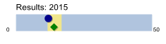
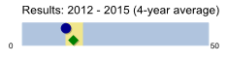
Prep | Yr1 | Yr2 | Yr3 | Yr4 | Yr5 | Yr6
94 % | 92 % | 94 % | 94 % | 92 % | 94 % | 95 %

  Average Number of Student Absence Days
  Average days absent per full time equivalent (FTE) student per year. Common reasons for non-attendance include illness and extended family holidays.
  Absence from school can impact on students’ learning. A school comparison rating of ‘lower’ indicates that the absence rate in this school is greater than what we would estimate, given the background characteristics of their students.
  Average 2015 attendance rate by year level:
  

  Performance Summary
  Wellbeing
  Student Outcomes
  School Comparison
  Students Attitudes to School -
  Connectedness to School
  Measures the Connectedness to School factor derived from the Attitudes to School survey completed annually by Victorian government school students in Years 5 to 12. The school's average score is reported here on a scale of 1 to 5, where 5 is the highest possible score.
  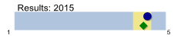
  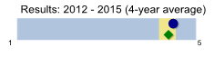
  Students Attitudes to School -
  Student Perceptions of Safety
  Measures the Student Perceptions of Safety factor derived from the Attitudes to School survey completed annually by Victorian government school students in Years 5 to 12. The school's average score is reported here on a scale of 1 to 5, where 5 is the highest possible score.
  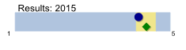
  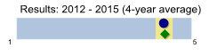

  How to read the Performance Summary
  What are student outcomes?
  Student outcomes show the achievements of students in this school in English and Mathematics. They also show results in national literacy and numeracy tests and, for secondary colleges, the Victorian Certificate of Education (VCE) examinations. They provide important information about student attendance and engagement at school.
  For secondary colleges, the Performance Summary also provides information about how many students at this school go on to further studies or full-time work after leaving school.
  You can see these results for the latest year, as well as the average of the last four years (where available).
  The Performance Summary also allows you to compare student outcomes for students at this school with the outcomes of students in all other Victorian government schools.
  What is a School Comparison?
  The School comparison is a way of comparing school performance that takes into account the different student intake characteristics of each school.
  A School comparison takes into account the school’s academic intake, the socio-economic background of students, the number of Aboriginal students, the number of non-English speaking and refugee students, the number of students with a disability, and the size and location of the school.
  The School comparison measures show that most schools are doing well and are achieving results that are ‘similar’ to what we would estimate given the background characteristics of their students. Some schools are doing exceptionally well with the students they have, and have ‘higher’ performance. Some schools have ‘lower’ performance after taking into account their students’ characteristics – these schools will receive targeted support to ensure that there is improvement.
 |  | 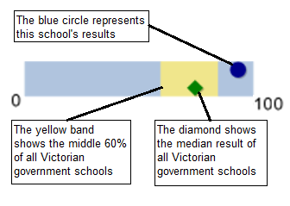
 |  |  |  |  |  |  |  |  | 
Looking at both the student outcomes and school
comparisons provides important information about what
a school is doing well and the areas that require further
improvement.

More information on school comparison performance
measures can be found at:
http://www.education.vic.gov.au/school/principals/manage
ment/pages/performreports.aspx

What is the meaning of ‘Data not available’?

For some schools, there are too few students to provide
data. For other schools, there are no students at some
levels, so school comparisons are not possible. Newly
opened schools have only the latest year of data and no
averages from previous years. The Department also
recognises the unique circumstances of Specialist, Select Entry, English Language and Community Schools where
school comparisons are not appropriate.

What is this school doing to improve?

All schools have a plan to improve outcomes for their
students. The ‘About Our School’ statement provides a
summary of this school’s improvement plan.

Additionally, NAPLAN learning gain charts are provided for each of the NAPLAN domains. These compare a student's current year NAPLAN result to the results of all ‘similar’ Victorian students (i.e. students in all sectors in the same year level who had the same NAPLAN score two years prior).

If the current year result is in the top 25% their gain level is categorised as ‘High’, the middle 50% is categorised as ‘Medium’ and the bottom 25% is categorised as ‘Low’.

 |  | 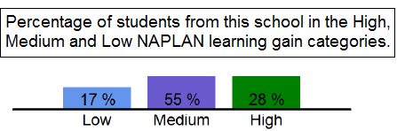
  Results for students working within Towards Foundation Level AusVELS (AusVELS A-D) show the percentages of these students making progress below, at and above the expectations of their schools.
 |  |  | 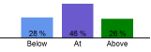

  Financial Performance and Position
  Financial Performance - Operating Statement
  Summary for the year ending 31 December, 2015
  Financial Position as at 31 December, 2015
  Revenue
  Actual
  Funds Available | Actual
  High Yield Investment Account | $39,481
  Official Account | $25,845
  Other Accounts | $154,585
  Total Funds Available | $219,911
  Student Resource Package
  $1,787,955
Government Provided DET Grants | $305,001
Government Grants Commonwealth | $6,892
Revenue Other | $18,086
Locally Raised Funds | $258,236

  Total Operating Revenue
  $2,376,170
  Expenditure
  Financial Commitments
  Operating Reserve | $89,588
  Asset/Equipment Replacement < 12 months | $30,000
  Maintenance - Buildings/Grounds incl SMS<12 months | $20,000
  Revenue Receipted in Advance | $23,939
  School Based Programs | $5,000
  School/Network/Cluster Coordination | $9,065
  Provision Accounts | $5,000
  Asset/Equipment Replacement > 12 months | $20,000
  Capital - Buildings/Grounds incl SMS>12 months | $5,000
  Maintenance -Buildings/Grounds incl SMS>12 months | $12,320
  Total Financial Commitments | $219,911
  Student Resource Package
  $1,751,244
Books & Publications | $2,151
Communication Costs | $5,730
Consumables | $71,250
Miscellaneous Expense | $140,014
Professional Development | $8,944
Property and Equipment Services | $115,987
Salaries & Allowances | $135,132
Trading & Fundraising | $50,494
Utilities | $22,452
Adjustments | $590

  Total Operating Expenditure
  $2,303,988
  Net Operating Surplus/-Deficit
  $72,183
  Asset Acquisitions
  $0
Student Resource Package Expenditure figures are as of 21 March 2016 and are subject to change during the reconciliation process.

Misc Expenses may include bank charges, health and personal development, administration charges, camp/excursion costs and taxation charges.

Salaries and Allowances refers to school-level payroll.

  All funds received from the Department, or raised by the school, have been expended, or committed to subsequent years, to support the achievement of educational outcomes and other operational needs of the school, consistent with Department policies, School Council approvals and the intent/purposes for which funding was provided or raised.
  Financial performance and position commentary
  Belgrave South Primary School remains in a strong financial position at the end of 2015. This has set up for 2016 allowing for increased staffing to continue improve the capacity of teachers in our focus area of literacy and numeracy. This includes a full time Assistant Principal, casual Literacy Coach and SURF Maths teacher.

